THE INFLUENCE OF BIOLOGICAL PREPARATIONS AND THEIR MIXTURES ON SOIL AGROCHEMICAL PROPERTIES IN WINTER WHEAT

Name SURNAME, Affiliation (Department of ………, Faculty of …………, Institution, address), e-mail@.com (corresponding author)
Name SURNAME, Affiliation (Department of ………, Faculty of …………, Institution, address), e-mail@.com
Name SURNAME, Affiliation (Department of ………, Faculty of …………, Institution, ddress), e-mail@.com

The abstract should be about 200-250 words. The research article abstracts should give a pertinent overview of the work. We encourage authors to use the following structure: topicality, research methods, results, main conclusions, and keywords. The abstract should be an objective representation of the article and must not contain results not presented and not substantiated in the main text.

Keywords: keyword 1; keyword 2; keyword 3 (List three to ten pertinent keywords specific to the article yet reasonably common within the subject discipline.)

INTRODUCTION

The introduction should briefly place the study in a broad context and highlight why it is important. It should define the purpose of the work and its significance. The studied research field should be reviewed and important publications cited. Briefly mention the main aim of the work.

RESEARCH METHODS

The Materials and Methods should be described with sufficient details to allow others to replicate and build on the published results. Please disclose at the submission stage any restrictions on the availability of materials or information. New methods should be described in detail while well-established methods can be briefly described and appropriately cited.

RESEARCH RESULTS AND DISCUSSION

The Section of Results and Discussion might be prepared in one or divided into two parts. It should provide a concise and precise description of the experimental results, as well as the experimental conclusions that can be drawn. Authors should discuss the results and how they can be interpreted from the perspective of previous studies. The findings and their implications should be discussed in the broadest context possible. Future research directions may also be highlighted. This section may be divided by subheadings.

Figures, Tables and Schemes
All figures and tables should be cited in the main text as Figure 1, Table 1, etc.

Table 1. This is a table. Tables should be placed in the main text near to the first time they are cited.
Title 1 | Title 2 | Title 3
entry 1 | data | data
entry 2 | data | data ¹
Note: ¹ Tables may have a footer.

There were recommended to avoid screenshots of diagrams or other graphic information in the text, especially if the fonts of such images are significantly smaller than the main text font of the article. A consistent formatting style for charts, photographs, and other figures must be used throughout the text.
Figures should be placed in the main text near the first time they are mentioned.

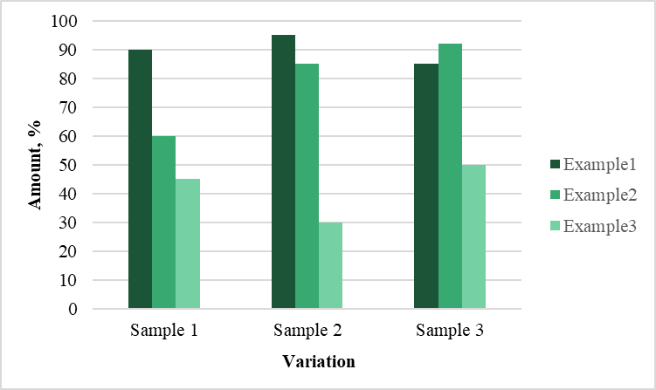
Figure 1. Title of the Figure.

a | b
Figure 1. This is a figure. Schemes follow another format. If there are multiple panels, they should be listed as: (a) Description of what is contained in the first panel; (b) Description of what is contained in the second panel.

Variables and equations are written using equation tools in Microsoft Word. Abbreviations of variables in text and in equations are presented in Italic. Equations are written in a new line, are centered and numbered in Arabic numbers in brackets and aligned to the right page margin. If the symbols or variable in equation does not require clarification or description, equation should be followed by a dot. If the variables are explained below, the equation is followed by a comma and the new line starts with a word “where” followed by explanation of each variable and its units. The example of the formula is given below:
$x=\frac{b+\sqrt{b^{2}-4ac}}{2d},$ (1)
where a – variable one, units;
b – variable two, units;
c – variable three, units;
d – variable four, units.

CONCLUSIONS

The conclusions reflect the main results of the study. Only the main conclusions based on the results of research are given.

Acknowledgements. Provide here any additional information concerning research grants.

REFERENCES

The list of references is alphabetical by the family name of the author or the first word of the source title. The list of references provides first the Latin character publications. Non-Latin font sources must be transliterated. All titles of references in non-English language must be translated to English. Internet sources must be interactive. Several works by the same author are listed in chronological order. Works by the same author and published in the same year are listed as follows: 2019a, 2019b, etc..
No abbreviations should be used in the list of references, all co-authors and full title of the reference should be provided. References are numbered in the list. Detailed information about APA citation style can be found at https://biblioteka.vdu.lt/en/for-research/how-to-cite/apa-american-psychological-association/

- Surname, N. (Year). Article title: Subtitle. Journal title, Volume(No.), pages xx–xx
- Surname1, N., Surname2, N., & the last author‘s surname, N. (Year). Article title: Subtitle. Journal title, Volume(No.), pages xx–xx.
- Surname, N. (Year). Article title: Subtitle. Journal title, Volume(No.), pages xx–xx. http://doi:10.XXXX/XXX.
- Surname1, N., Surname2, N., & the last author‘s surname, N. (Year). Book title: Subtitle. Location: Publisher.
- Surname, N. (Year). Title of chapter: Subtitle. In Book title: Subtitle (pp. xx–xx). Location: Publisher.
- Surname, N./Name of organization. (Year). Website/document title. Available at: http://www.internetaddress.lt
- Surname1, N., Surname2, N., & the last author‘s surname, N. Title of Unpublished Work. Abbreviated Journal Name year, phrase indicating stage of publication (submitted; accepted; in press).
- Surname, N. Title of Thesis. Level of Thesis, Degree-Granting University, Location of University, Date of Completion. Title of Site. Available online: URL (accessed on Day Month Year)

